

HARSHA INSTITUTE OF MANAGEMENT STUDIES

ANNUAL REPORT OF THE ACADEMIC YEAR 2023-2024

INTRODUCTION
Welcome to Harsha Institute of Management Studies. As an institution committed to fostering excellence in business education and leadership, this report offers a comprehensive overview of our achievements, progress, and initiatives over the past year. In a rapidly evolving world, where global challenges and technological advancements reshape industries, our goal has remained constant—to equip future leaders with the skills, knowledge, and mind set required to thrive in dynamic environments. Through a blend of innovative teaching methods, real-world learning experiences, and a strong focus on personal and professional growth, Harsha Institute of Management Studies continues to uphold its mission of providing quality education.
This year, we have made remarkable strides in academic excellence, industry collaborations, research contributions, and student success. As we reflect on these milestones, we also look ahead to the future, confident in our ability to adapt to emerging trends and continue providing transformative educational experiences.

HIGHLIGHTS ON THE INSTITUTIONAL DEVELOPMENT:

Vision:
"To be a leading institute that nurtures innovative, ethical, and globally competitive leaders through transformative education and practical exposure, empowering them to make impactful contributions to society and the business world."

Mission:
• To provide a holistic learning environment that fosters intellectual growth, critical thinking, and leadership skills.
• To be committed to delivering high-quality management education through industry-focused curriculum, practical learning, and continuous development of our students to shape them into responsible and proficient business leaders.

Motto:
"Empowering Minds, Shaping Futures"

INSTITUTIONAL ACHIEVEMENTS
- Signed an MOU and collaborated with IBM.
- Completed graduation ceremony for MBA, MCA, BBA, and B.COM for the academic year 2021-23.
- Achieved The World Record as 948 students participated in Global Yoga Day.
- From MBA 52 Students have placed in various companies.
- From MCA 8 Students have placed.
- From BBA 6 students have placed.
- From B.COM 1 Student has placed.

FUTURISTIC PLAN
- Initiatives of certificate courses on logistics like Global Logistics and International Trade, Sustainability in Logistics and Logistics Technology etc….
- Establishing English language lab, literary and linguistic clubs of various languages.
- Institutionalizing of Forensic toxicology in the main stream of Forensic Science.
- Initiating incubation cell for nurturing business professionalism among upcoming graduates.
- Leveraging AI for market analysis, customer behavior prediction, and streamlining business processes. Automation could be applied to repetitive tasks like inventory management, data entry, and even customer service (e.g., chatbots).
- To prepare for Multidisciplinary Interdisciplinary Courses and Research Activities.
- To prepare for development of skills laboratories for improved quality of training.

DEPARTMENTAL ACTIVITIES

DEPARTMENT OF FORENSIC SCIENCE

World Forensic Science Day Celebration

On September 30, 2024 the department of forensic science of Harsha Institute of Management Studies hosted the day that is remarkable in the field of forensic science, which was volunteered by fifth semester students of the department, by conducting a poster presentation competition .
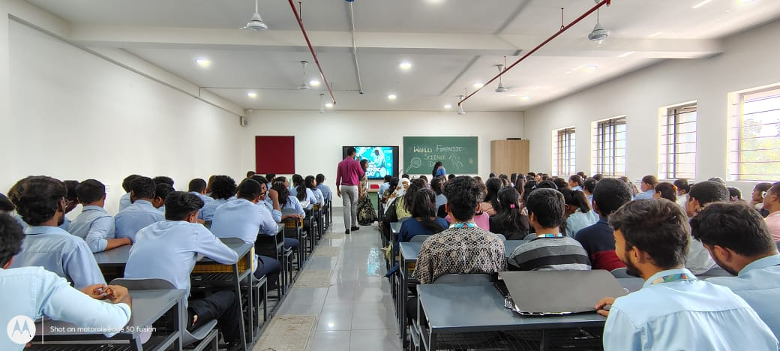
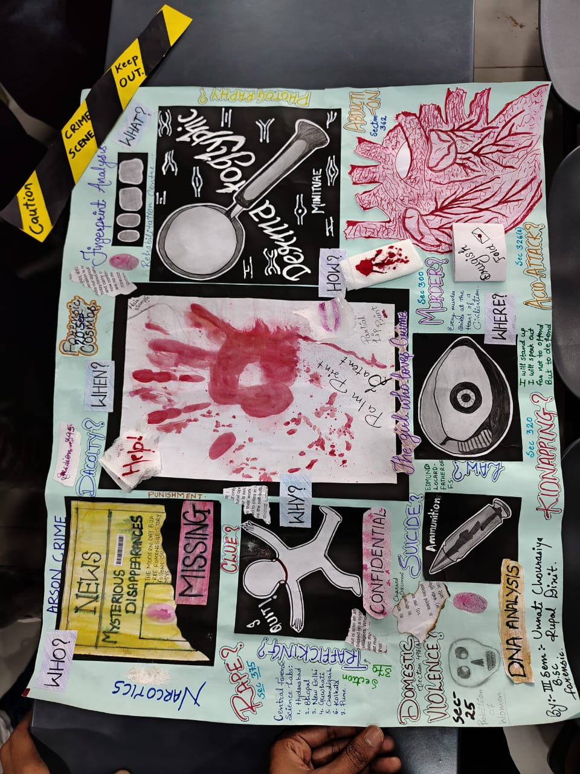

Visit to M.S. Ramaiah Medical College: Post Mortem and Central Medical Museum

The stuents of the 2nd and 3rd year BSc Foresic Science students were accompanied by Head of Department Deepika Devdas Patkar and Assistant Professor Atul Raj to M.S. Ramaiah Medical College for post mortem and central medical museum visit.
The day began with a detailed session on post mortem procedures conducted by Dr. Girish, who provided an insightful
introduction into the significance, methodology, and challenges of conducting postmortems.
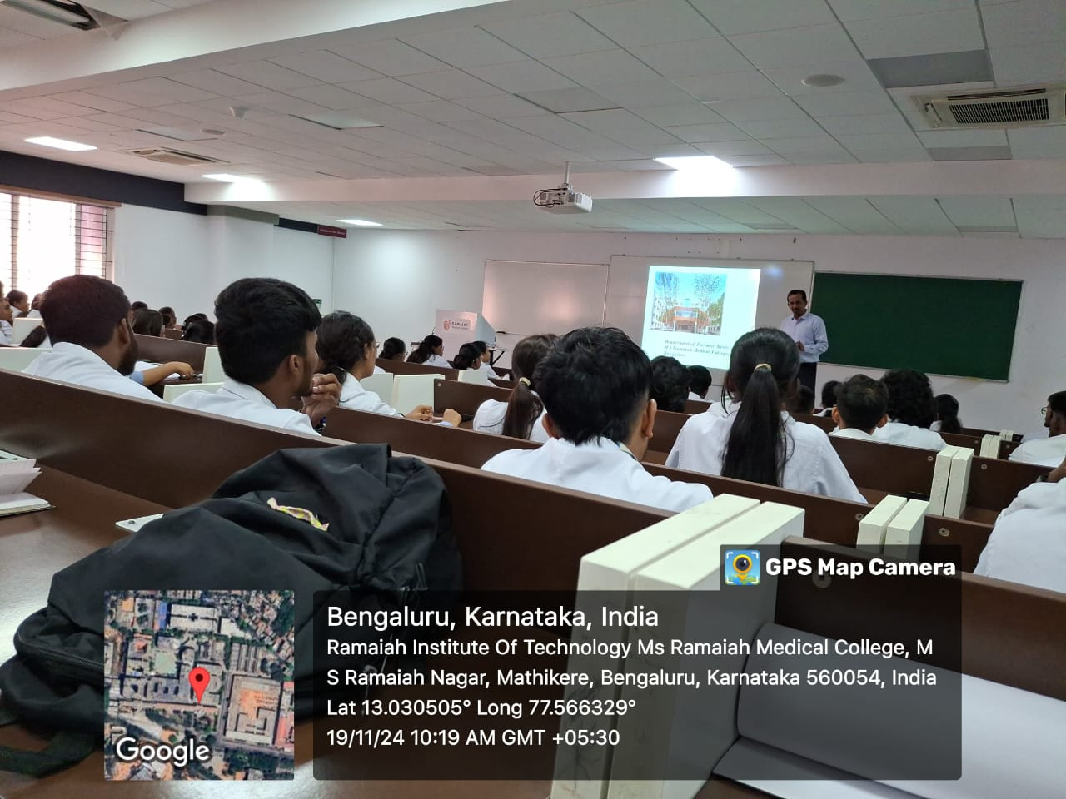
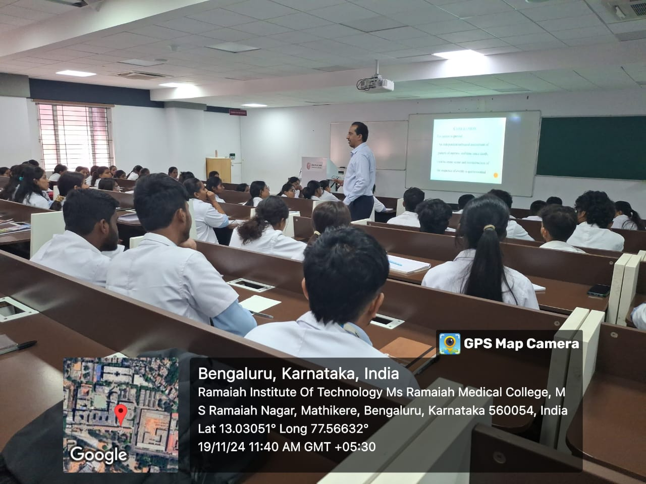

Report on the One- Day prison visit
The students from the department of forensic science along with the Head of the department and faculties made a visit to the Open air prison in Devanahalli,Karnataka on 12 December 2023.
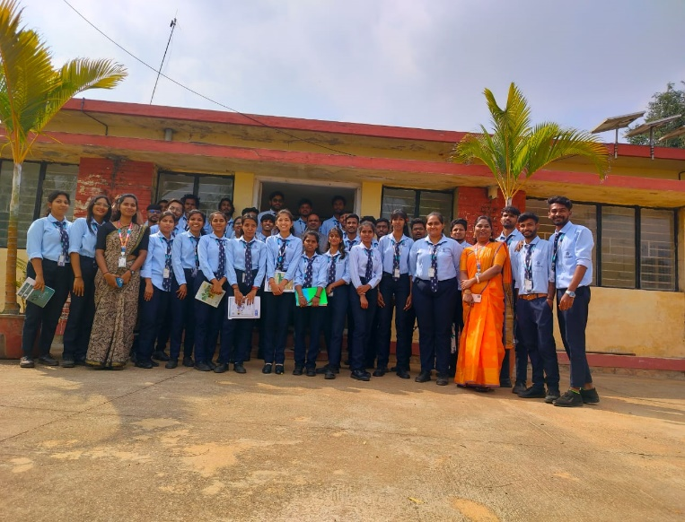
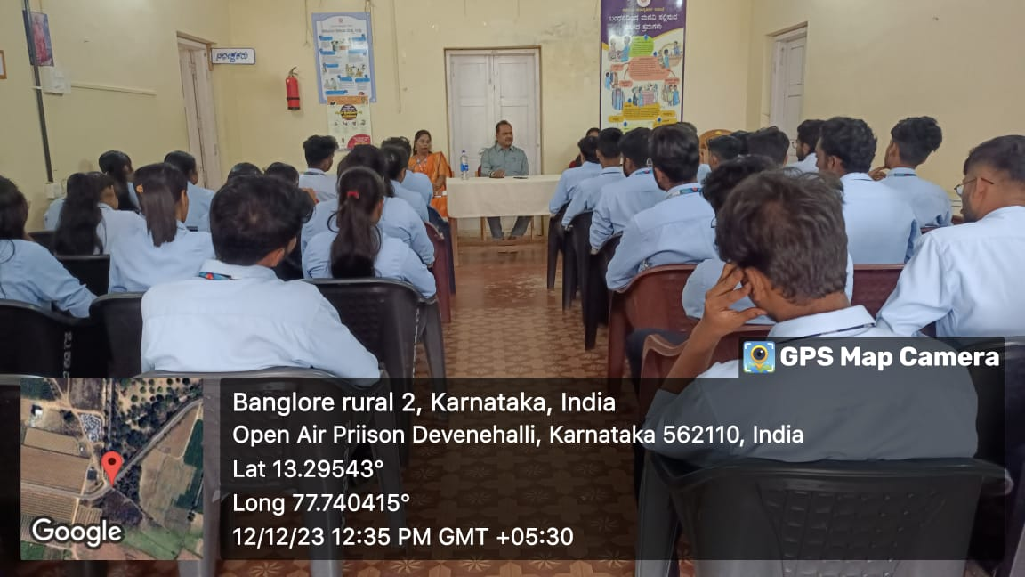

Guest Lecture on Criminal Law

Guest Lecture was conducted by the department forensic science, Harsha Institute of Management Studies on criminal law on 9TH August 2023. The chief guest of the lecture was Ms. Roja Rani She is a Phd scholar in Law and an advocate in the High Court of Karnataka.

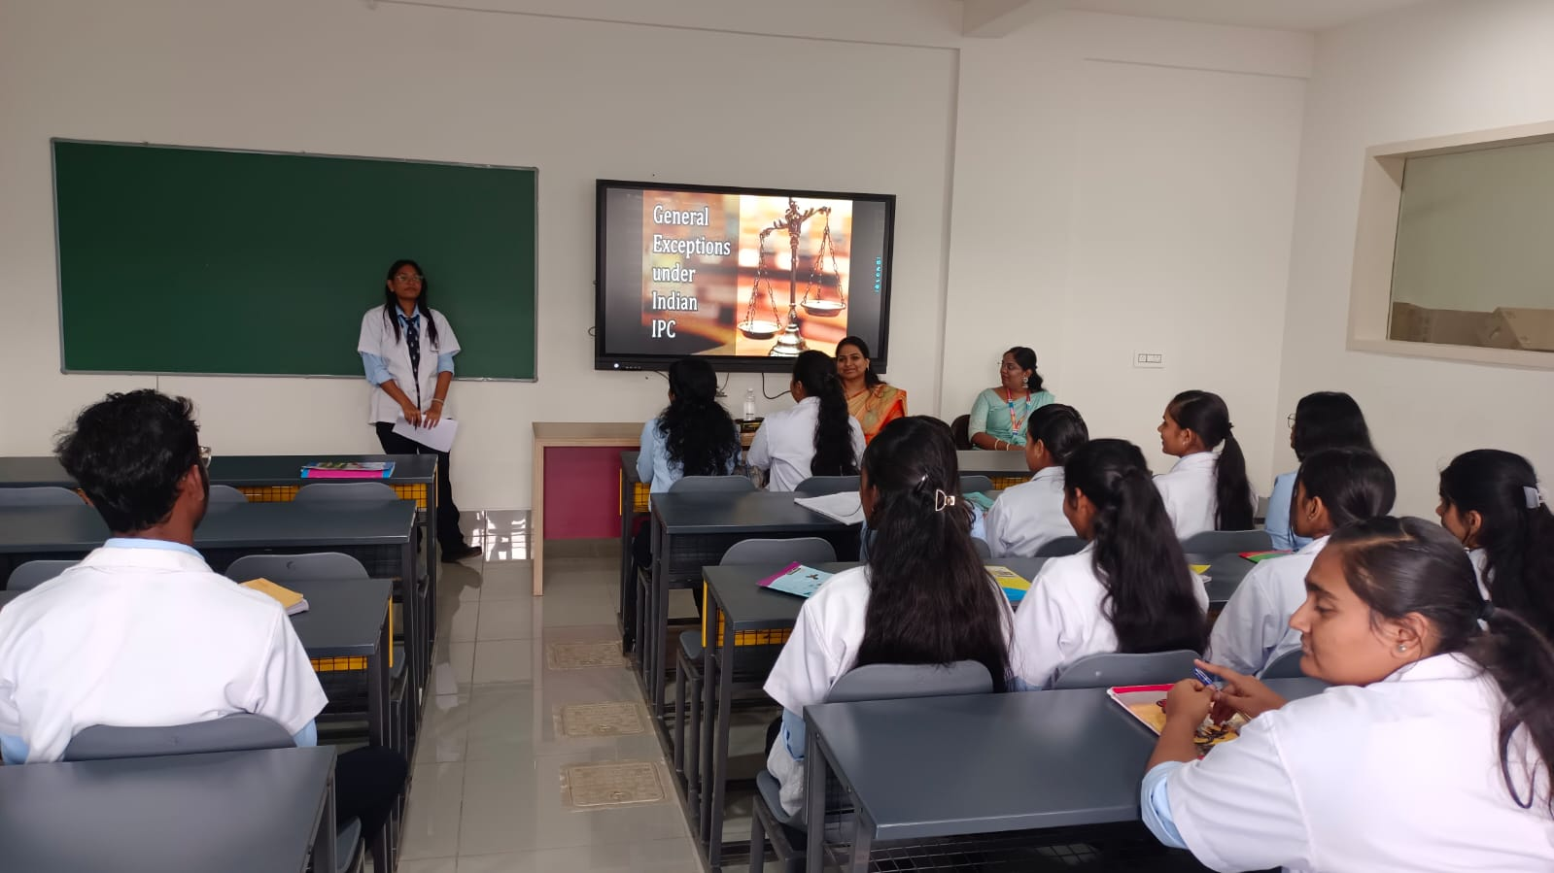
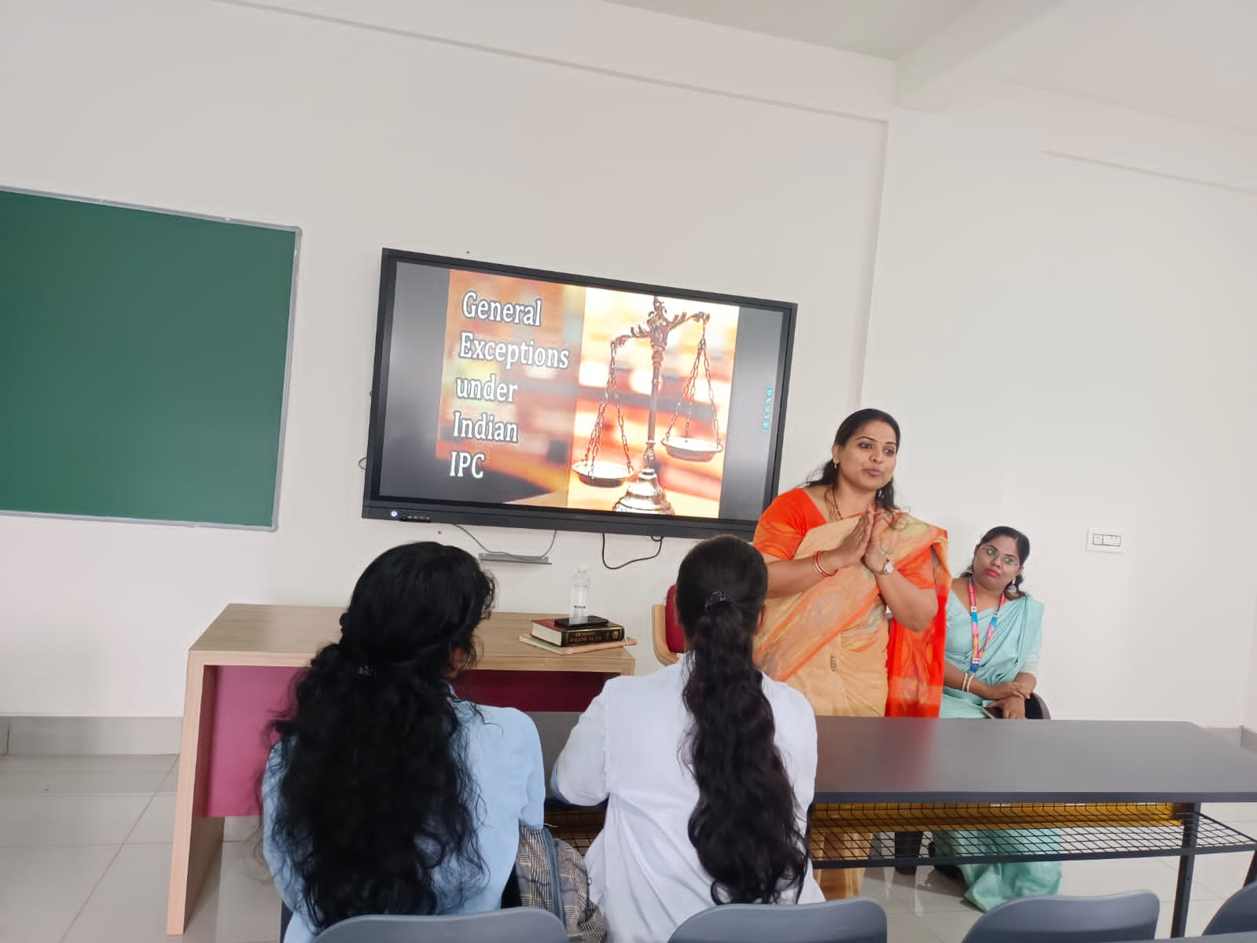

Guest Lecture On Criminology And Victimology

An event of guest lecture on criminology and victimology was organised in Harsha Institute Of Management Studies for department of forensic science. Mr Hemanth Kumar V imparted knowledge from his years of experience and expertise in this field.
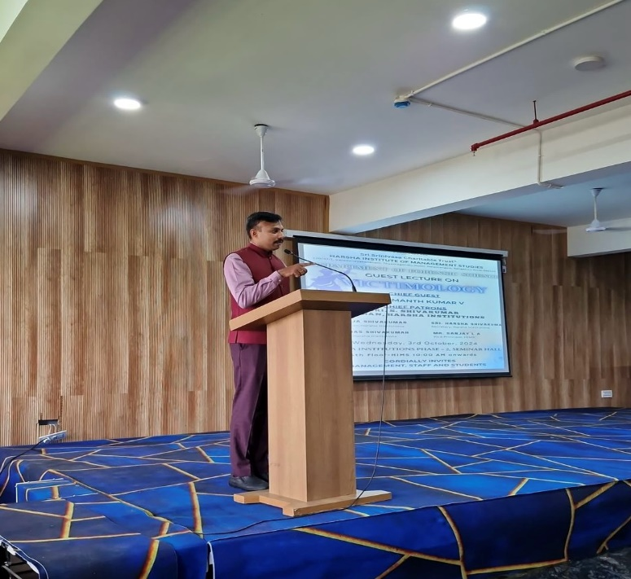

- Department of MCA

- On 23rd September 2024, the Department of Computer Applications, Harsha Institute of Management Studies organized a Guest lecture on the topic of Cloud Computing by Prof Shailesh Prasad, Head, Department of Computer Applications, East West College of Management Studies. The event was held at HIMS for MCA students, aimed at providing them with insights into the current trends and applications of the cloud computing, one of the most prominent fields in IT today.
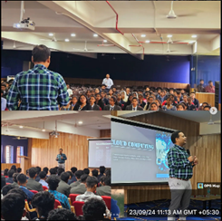

- A workshop on AngularJS Website Page Creation was conducted on 28th September 2024 at the Harsha Institute of Management Studies, organized by the Department of Computer Application for MCA students. The workshop was facilitated by the Guest Mr. Naveen J, Assistant Professor of the Department of MCA, AIMS Institute Peenya, who has served as the session's chief guest and resource person.

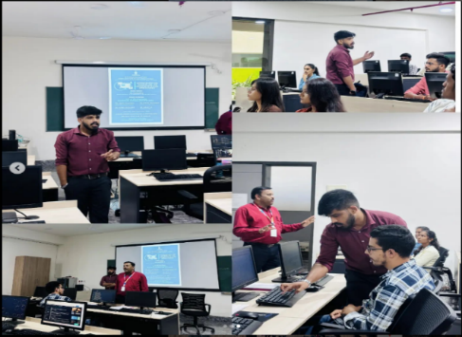

- 20th September 2024, the Department of Computer Applications at Harsha Institute of Management Studies organized an engaging event titled "Huddle and Hustle" for the MCA students. The event was aimed at enhancing both their group discussion skills and aptitude-solving capabilities, crucial for academic and professional growth.

- 30 August 2024 the MCA students organized a Product Launch Session. The session was a platform for students to present innovative ideas and demonstrate their technical skills by launching various products they had developed as part of their academic projects.

- Department of MBA

Corporate Transition leadership and placement training

The department of MBA organized a campus drive on corporate transition leadership and placement training programe in collaboration with CRACK-ED, official placement assisters for our postgraduate MBA and MCA students on 31st July 2024.We were honored with the presence of the chief guest Mr. Debojit Sen, founder and CEO of CRACK-ED, Ms. Bhavana Anand, corporations head, CRACK-ED and Mr. Nabeel Akthar, country head, CRACK-ED.
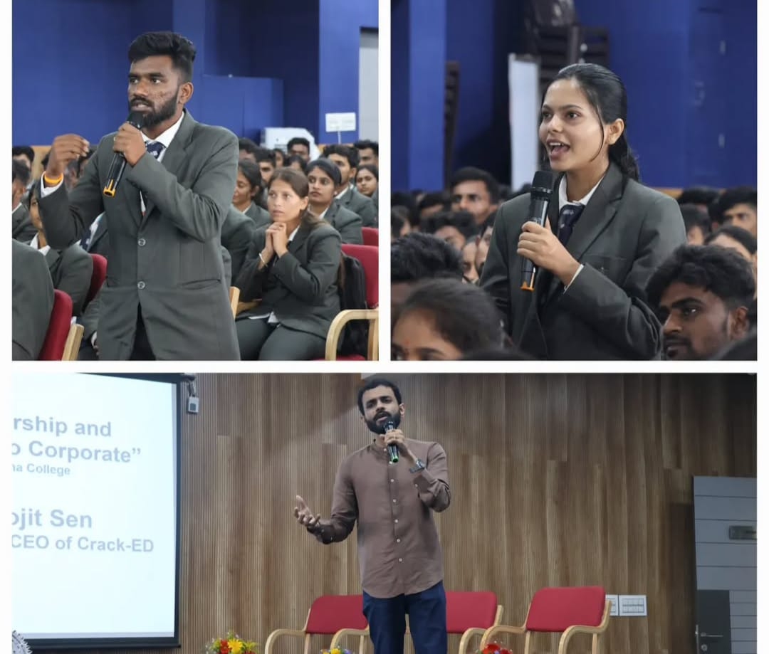
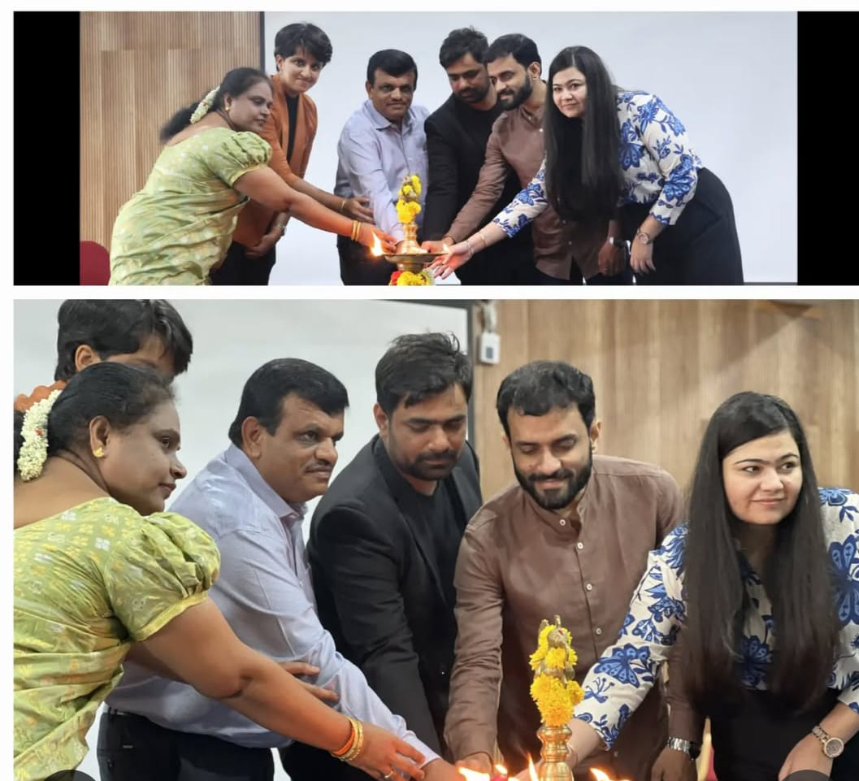

International visit to AMB Enstek

Our MBA students visited AJINOMOTO in Kuala Lumpur,Malaysia,gaining valuable insights. This visit provided a unique opportunity to observe advanced manufacturing processes and the use of cutting-edge technologyin the industry.
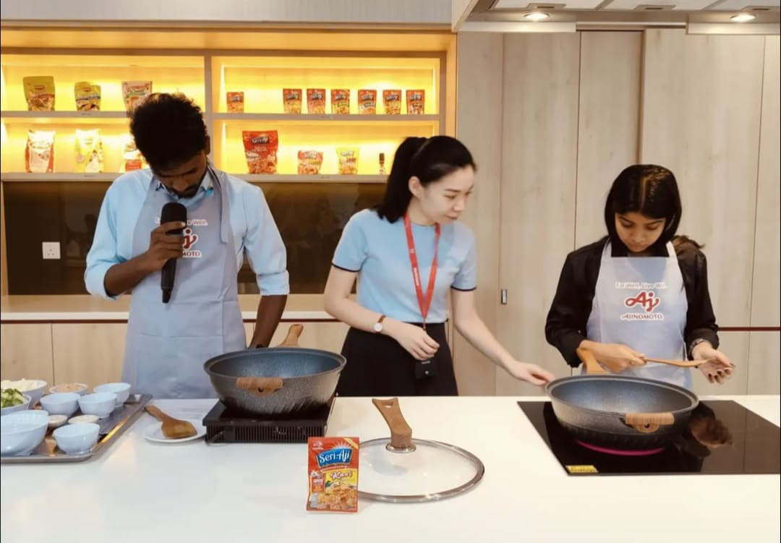
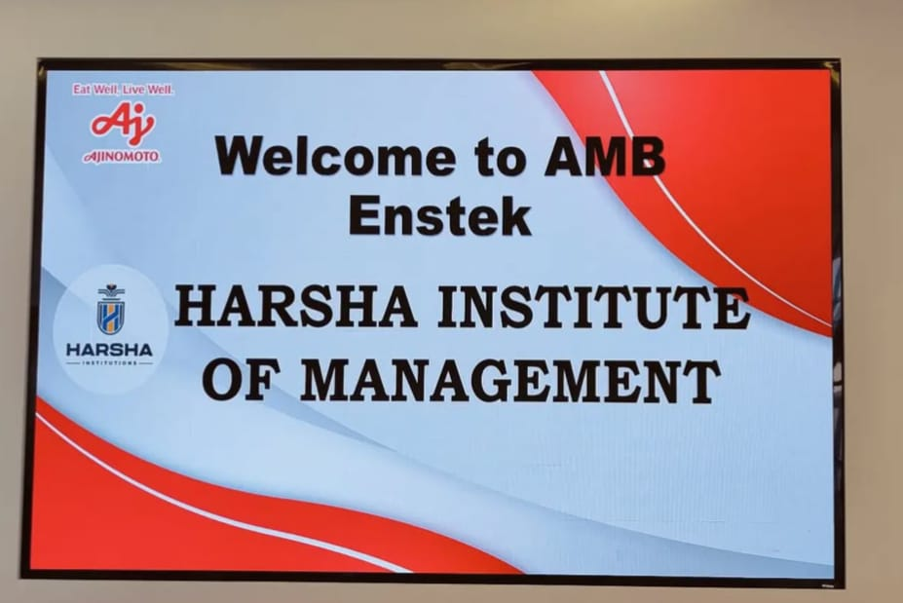

Workshop on Stock-Market

An insightful workshop on the stock-market led by Mr.Sujoy Roy, Deputy Vice President at Anand Rathi provided valuable knowledge and deeper understanding of market dynamics.
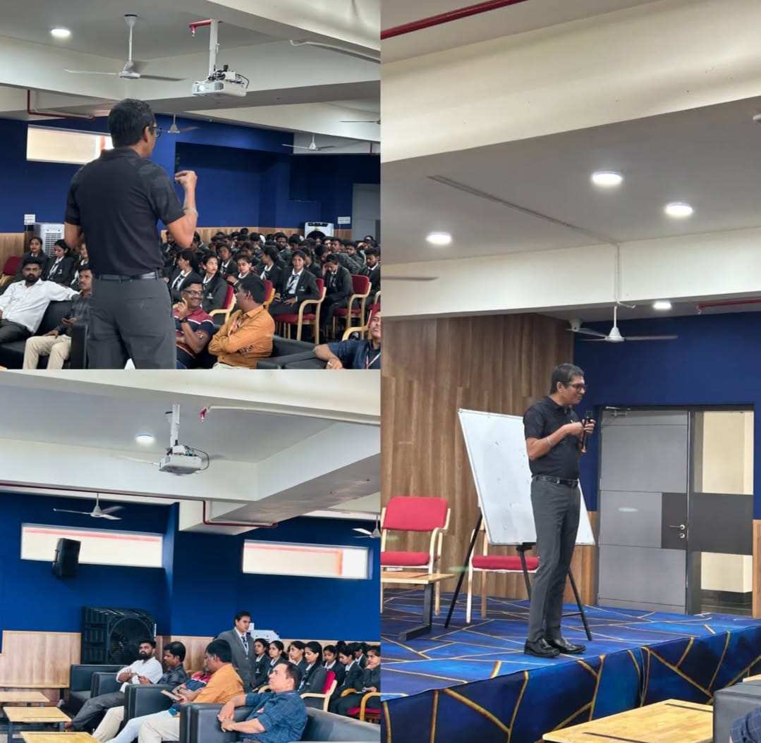
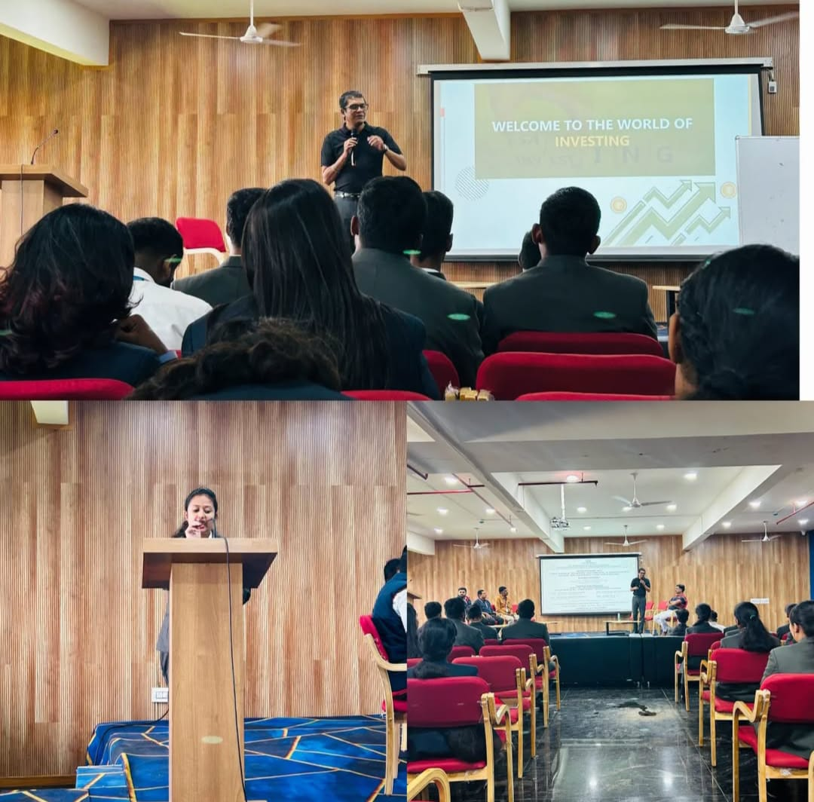

- Department of Commerce

Expert Talk on ‘Income tax specified: Key elements and Fundamentals’

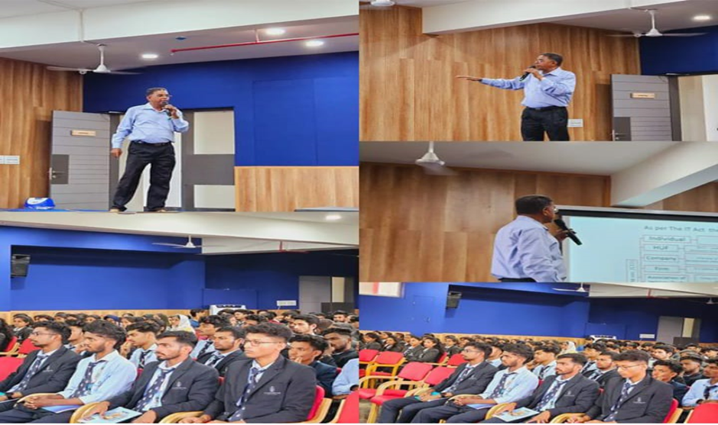
On 25/09/2024, an enlightening session was conducted at Harsha Institute of Management Studies by a Professional expert on the topic “Income tax specified: Key elements and Fundamentals” The session was organized with the aim of educating B.COM, BBA and MBA students about taxation, and its importance, Latest development in the field and how to effectively manage the personal income. And this event was mainly designed to provide students with comprehensive understanding of Income tax and filling procedures, Deductions, Current Slab Rate, Basic and Additional Conditions of Income Tax, Heads of the Income Tax Difference between early taxation and the Present taxation Income tax is considered as a one of the primary sources of revenue for governments worldwide, enabling them to fund Public services, infrastructure, defense and welfare programs. Understanding the basics of Income Tax is crucial for individuals and businesses to comply with tax laws and manage their financial responsibilities effective.
Industrial Visit to TVS Motors – Hosur
Harsha Institute of Management Studies organised an Industrial Visit to TVS Motors – Hosur, Tamil Nadu for B.com and BBA students. This visit aimed to provide students with a first hand understanding of the Functioning and Operations of one of India’s Largest two – wheeler manufacturers. This visit aimed to provide students with a firsthand understanding of the functioning and operations of one of India's largest two-wheeler manufacturers.
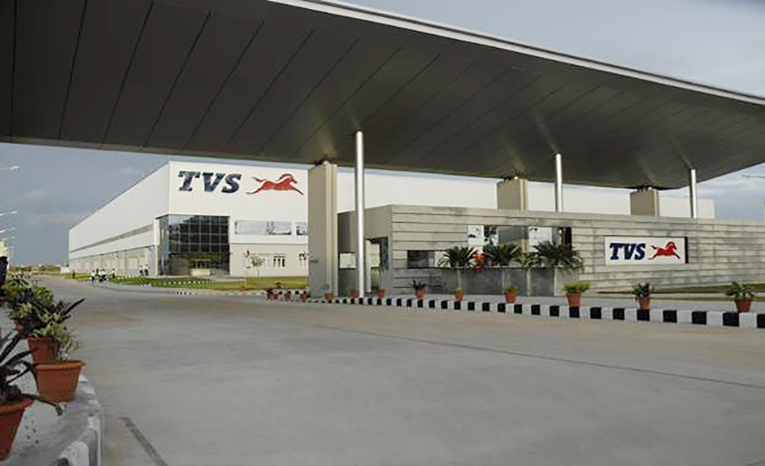

- DEPARTMENT OF COMPUTER APPLICATION

Guest Lecture on Cloud Computing

On 23rd September 2024, the Department of Computer Applications, Harsha Institute of Management Studies organized a guest lecture on the topic of Cloud Computing. The event was held at HIMS for both BCA and MCA students, aimed at providing them with insights into the current trends and applications of the cloud computing, one of the most prominent fields in IT today.

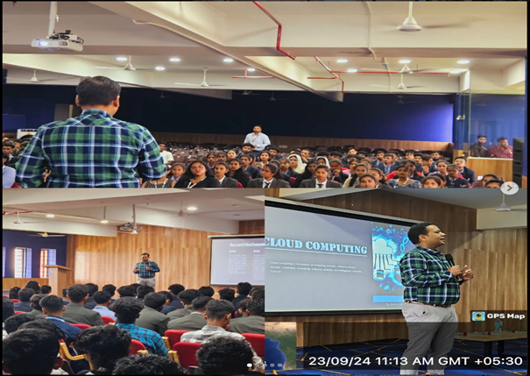
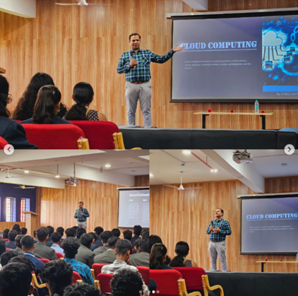

Product Launch

The MCA students organized a product launch session under the supervision of Mr. Jerin Varghese, Assistant Professor, MCA The session was a platform for students to present innovative ideas and demonstrate their technical skills by launching various products they had developed as part of their academic projects. The event was judged by Liby P Job, Assistant Professor and Dr. Lokesh Munni, Professor who evaluated the products based on creativity, functionality, and potential for real-world applications.

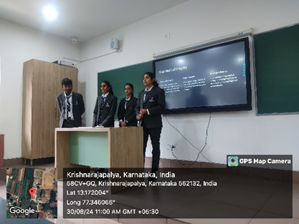
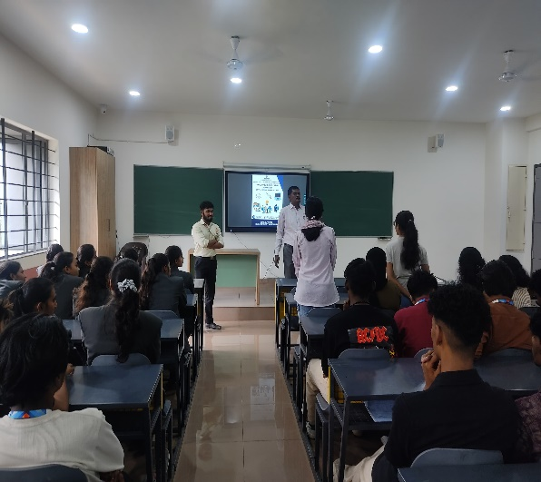

Workshop on Huddle and Hustle
On 20th September 2024, the Department of Computer Applications at Harsha Institute of Management Studies organized an engaging event titled "Huddle and Hustle" for the MCA 2nd semester students. The event was aimed at enhancing both their group discussion skills and aptitude-solving capabilities, crucial for academic and professional growth.

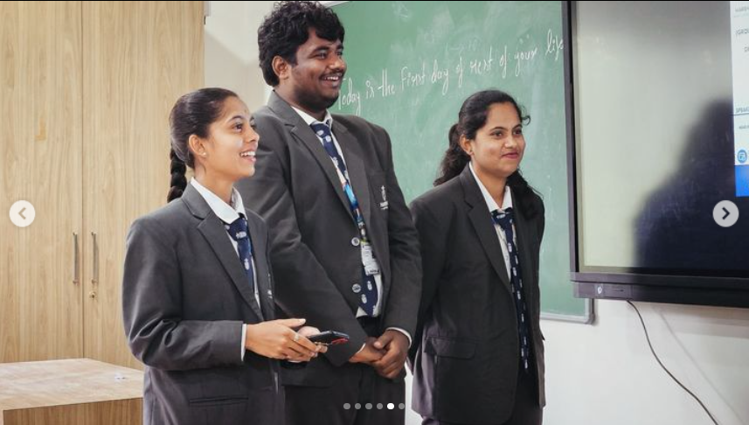
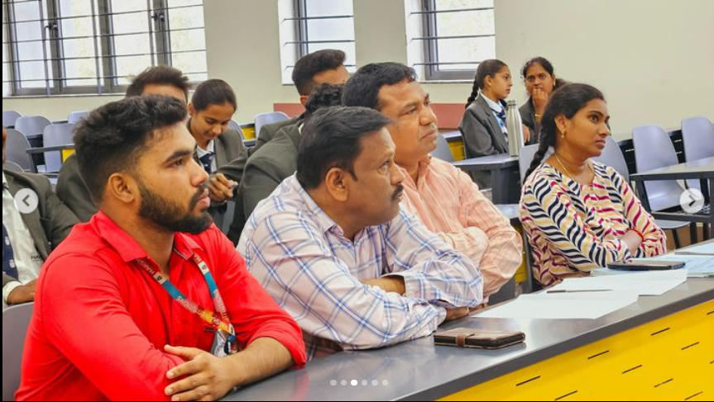

Workshop on Angular JS Website Page Creation
A workshop on AngularJS Website Page Creation was conducted on 28th September 2024 at the Harsha Institute of Management Studies, organized by the Department of Computer Application for the 5th-semester BCA and 2nd-semester MCA students. The workshop was facilitated by the Guest Mr. Naveen J, Assistant Professor of the Department of MCA, AIMS Institute Peenya.

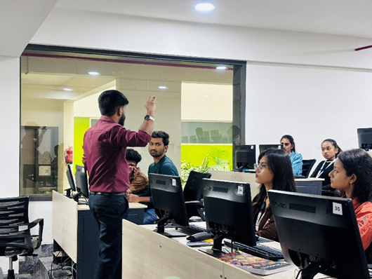
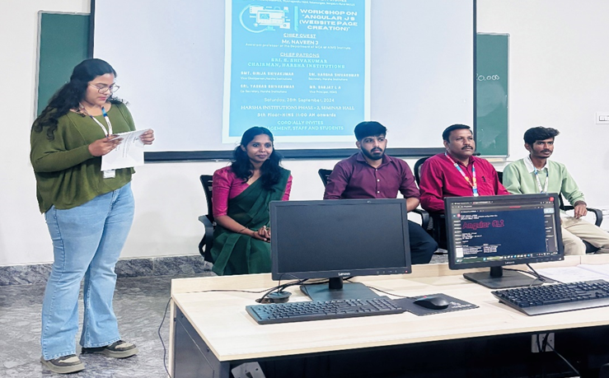

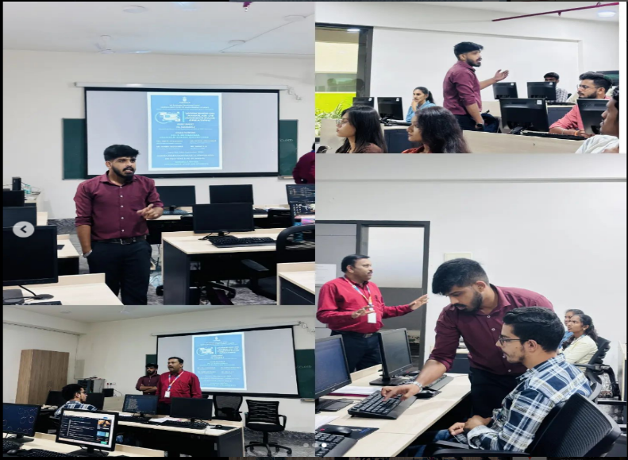

. OTHER ACTIVITES

GRADUATION CEREMONY

The graduation ceremony held on December 14, 2024, at Harsha Institute of Management Studies marked a significant milestone for over 500 students who successfully completed their programs across various disciplines. The event was inaugurated by the honorable chief guest Dr. Jayakara Shetty M, Vice-Chanceller of Bangalore University along with the Guest of Honor Mr. Chella Pandian Pitchai, HR Vice-President, Biocon, Bangalore. The event was attended by faculty, family members, friends, and distinguished guests, celebrated the hard work and accomplishments of the graduates and set the stage for their future endeavors.
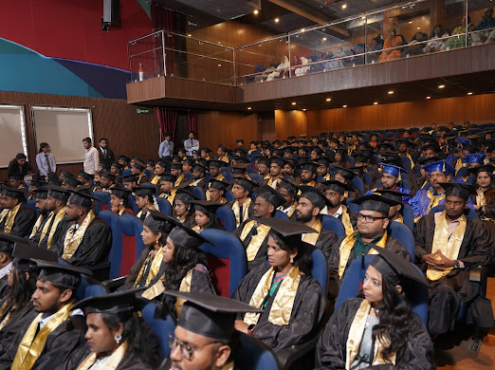
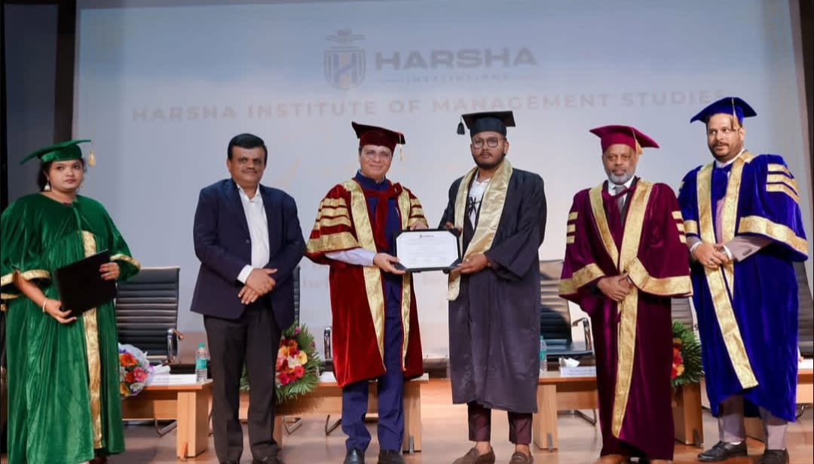

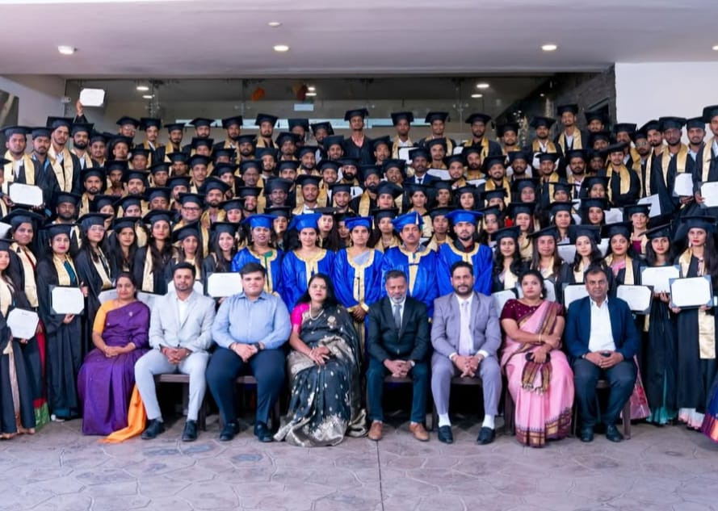

.

FDP ON NAAC PERSPECTIVES

A Faculty Development Program on NAAC perspectives was arranged with the presence of esteemed faculties and experts to enhance quality education and to build stronger academic foundation for our students.

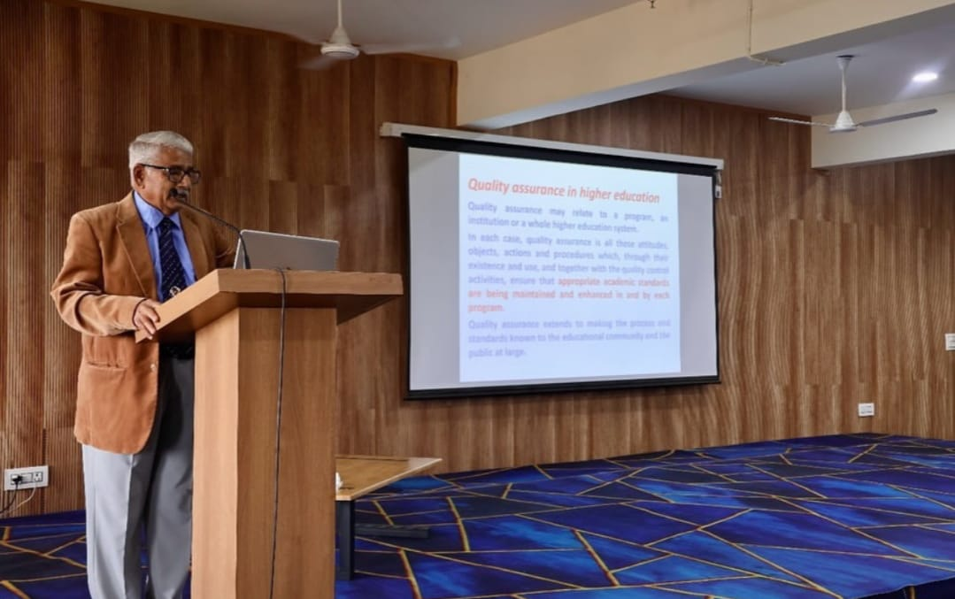
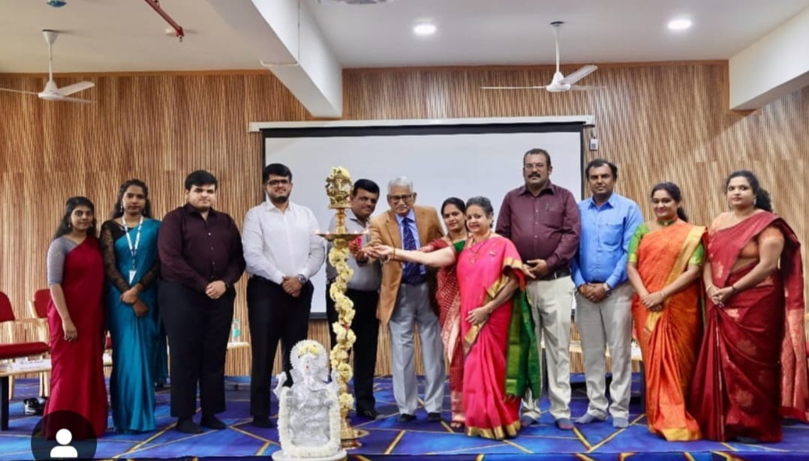

IBM CERTIFICATE ORIENTATION PROGRAM

IBM value –added Certification orientation program held at our campus for the students of BCOM, BBA, BCA, and B.SC Forensic Science. The session was held by renowned Suhas Malikarjun, a consultant and trainer in Information Security who provided a comprehensive overview of Cloud Computing, Artificial Intelligence and Machine Learning, Cyber Security, Date Science and Predictive Analysis.
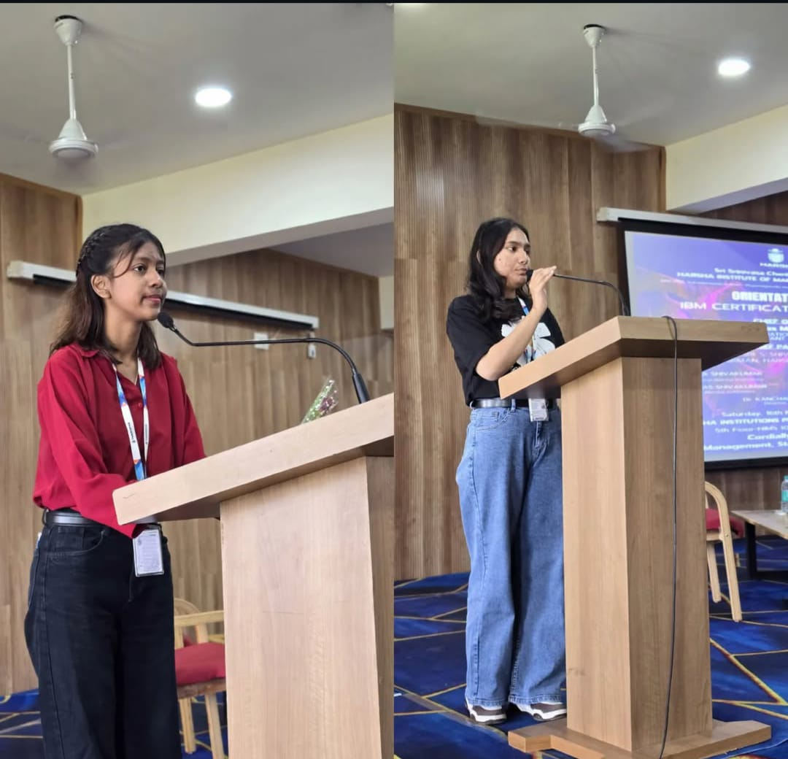
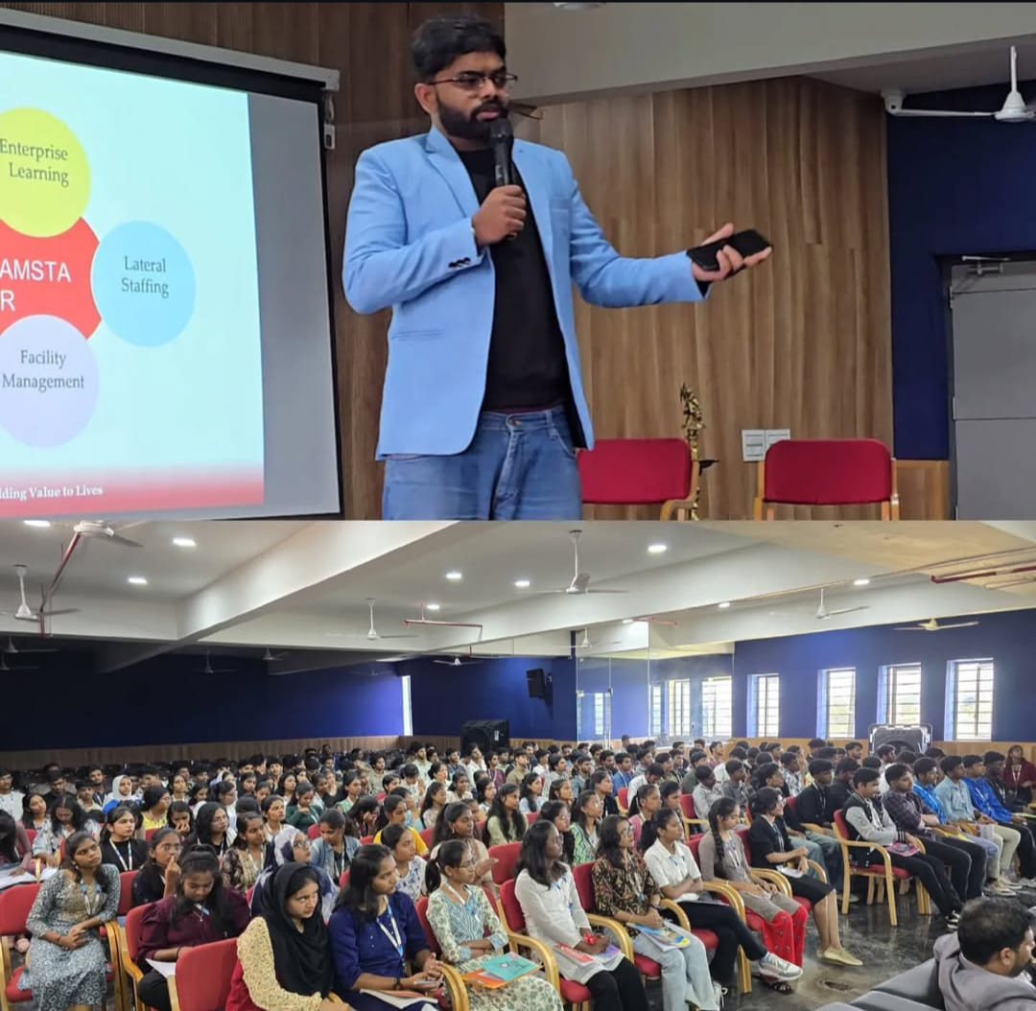

ACCA Program Orientation Program

We had an insightful orientation session on ACCA Program designed specifically for B.COM students. It was to explore the world of International Accounting and Finance. This session gave the exposure for the globally recognized qualification which open doors to numerous career path.
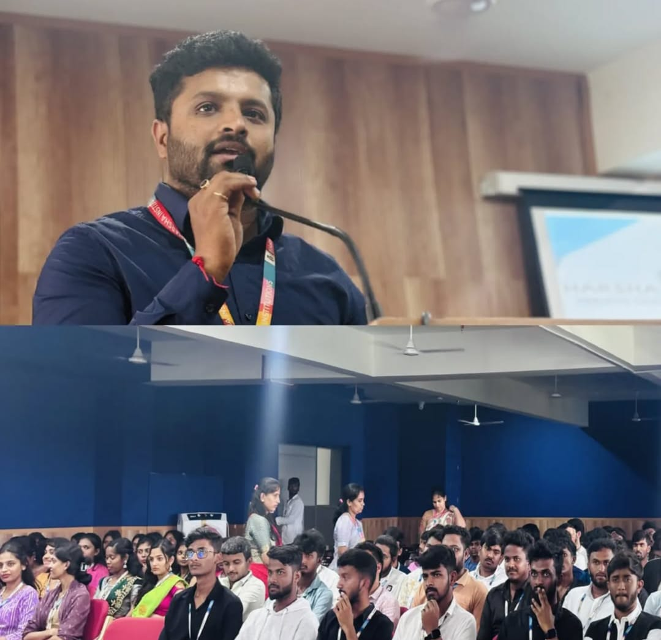
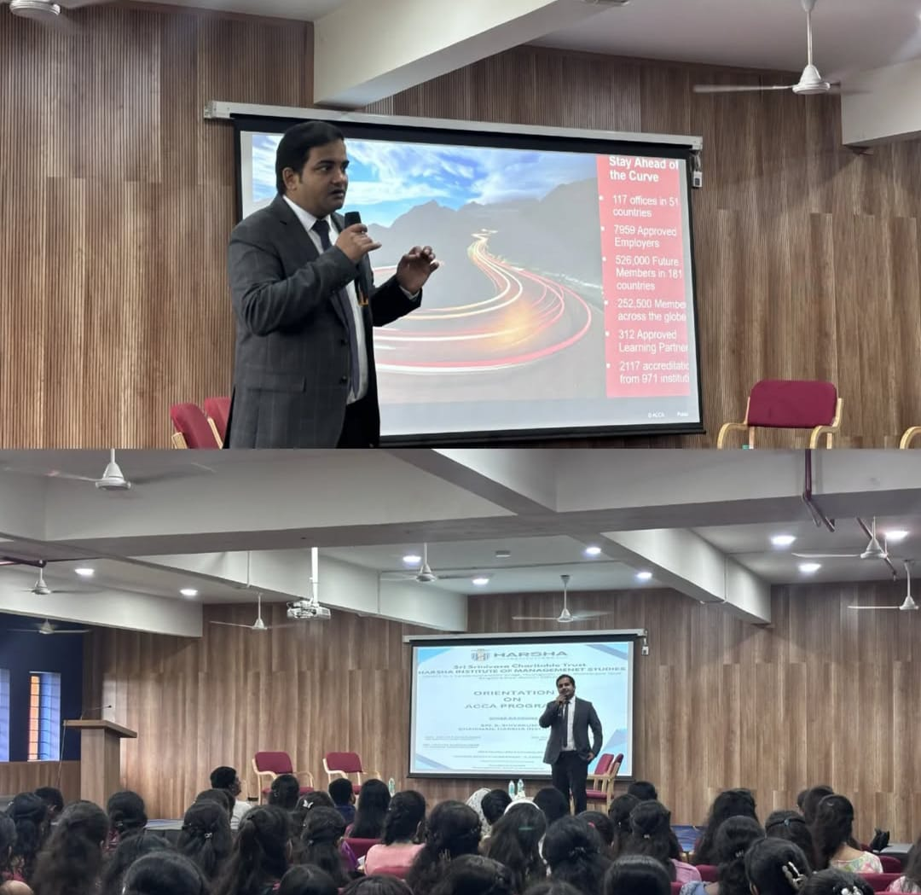

TEACHERS’ DAY CELEBRATION

On September 5, 2025, at Harsha Institute of Management Studies, celebrated Teacher’s Day with great enthusiasm and appreciation for the invaluable contributions of the teaching staff The event was organized to honor the hard work, dedication, and commitment of teachers who play a vital role in shaping the future of students. The celebration brought together students, teachers, and staff members in a joyous atmosphere filled with gratitude and respect.
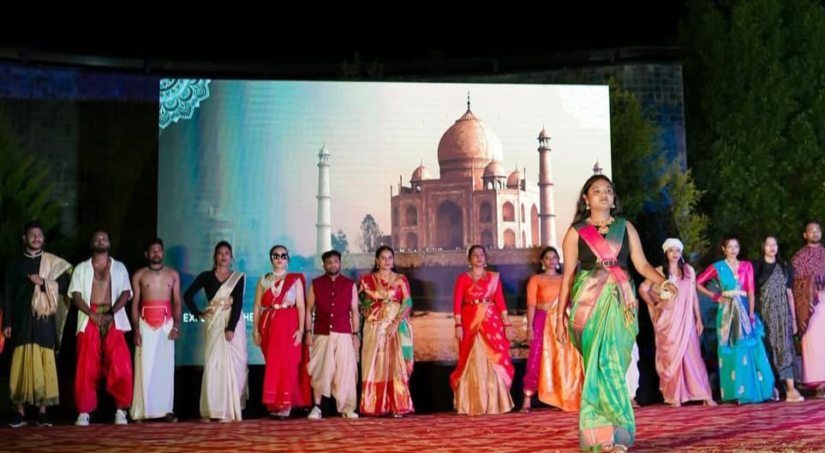
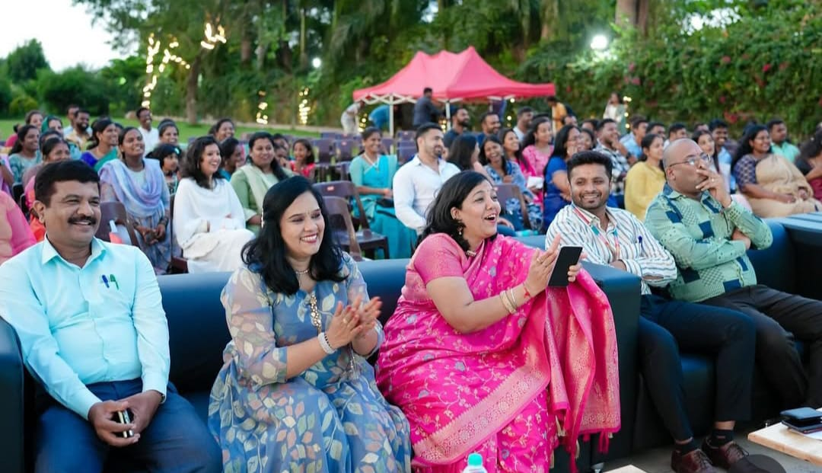

INDUSTRIAL VISIT TO MALAYSIA

Our students had an incredible opportunity to visit Royal Selangor, the world foremost name in quality pewter, known for its exceptional design and craftsmanship. This visit provided students with invaluable industrial insights.

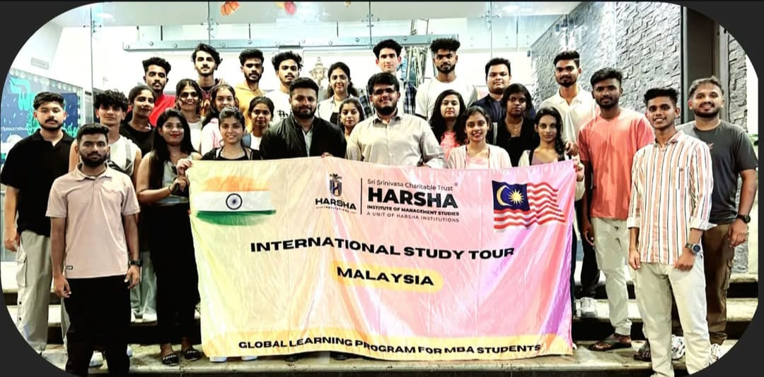

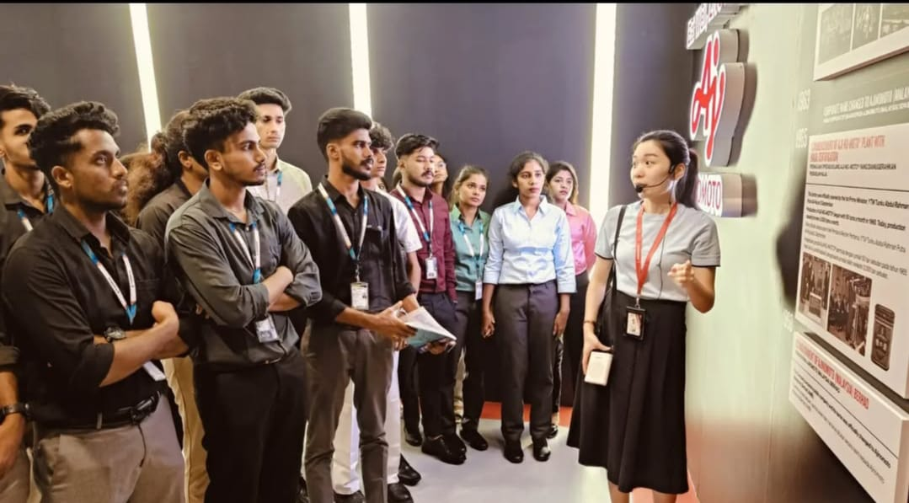
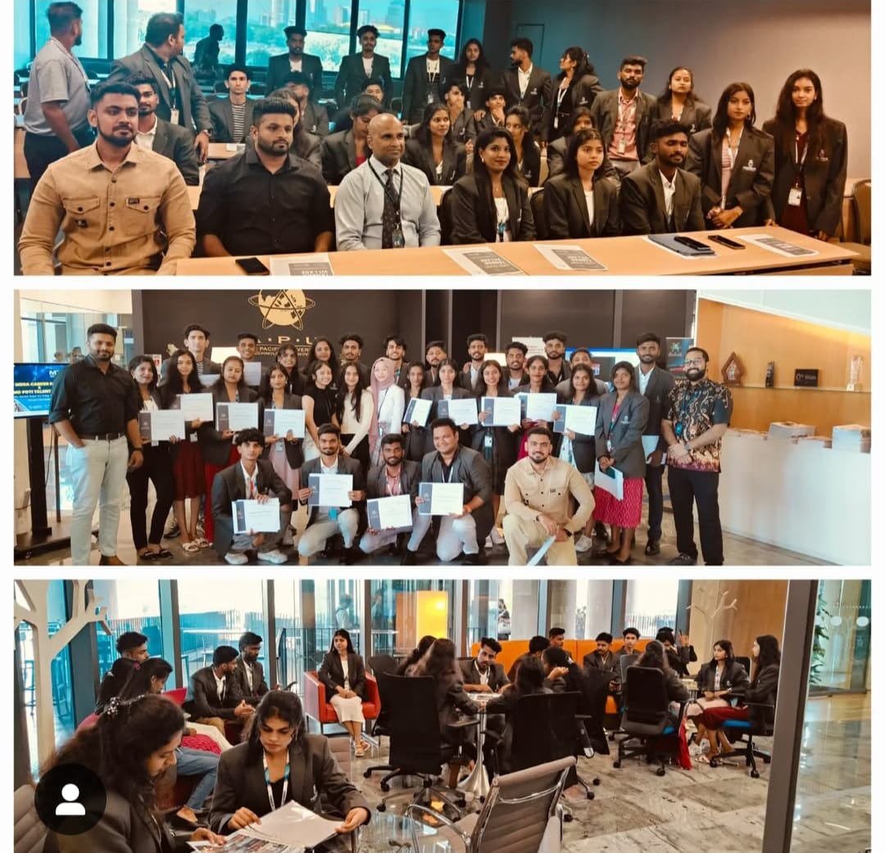

TRIP TO INTI INTERNATIONAL UNIVERSITY IN MALAYSIA:EXPLORING GLOBAL PERSPECTIVES

Our MBA students had an enriching educational trip to INTI International University in Malaysia. This experience has broadened their horizons and deepened their understanding of international business dynamics.
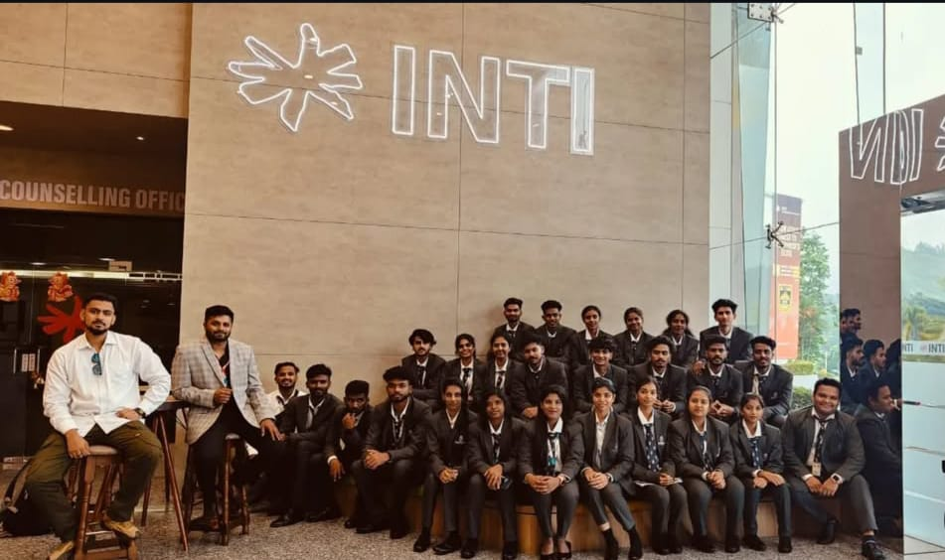
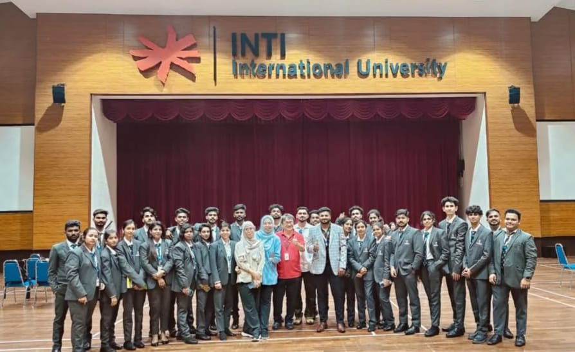

ONAM CELEBRATION:CULTURAL FEAST

On September 10, 2024, the students and faculties of Harsha Institute of Management Studies, celebrated the vibrant and cultural festival of Onam with great enthusiasm and joy. The event was a grand celebration of Kerala’s rich cultural heritage, bringing together students, teachers, and staff to partake in traditional festivities, performances, and delicious feasts. The celebration aimed to foster unity, promote cultural understanding, and provide a joyous experience for everyone involved.
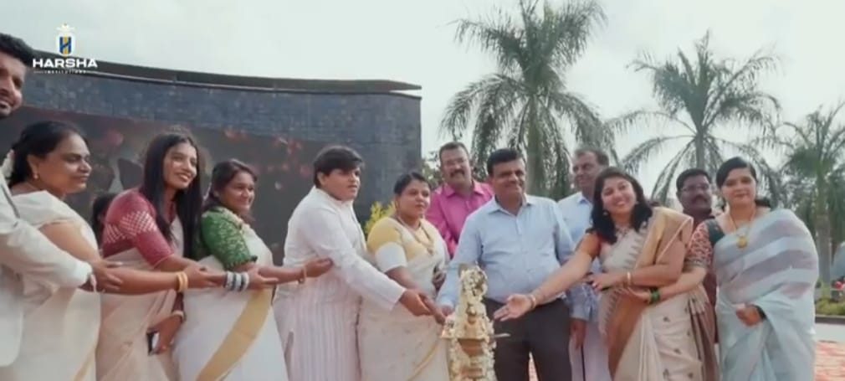
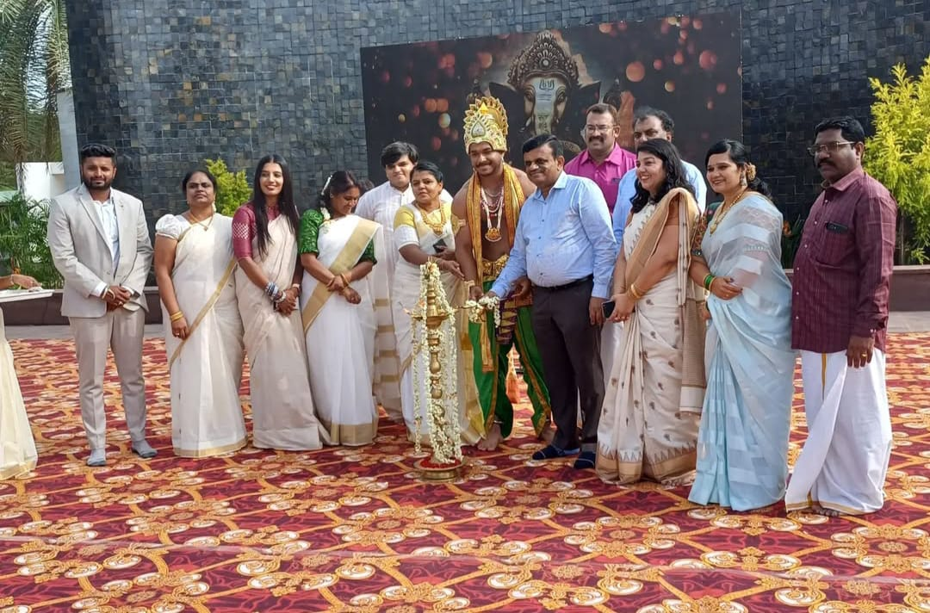

KANNADA RAJYOTSAVA DAY

The 69th Kannada rajyotsava day was celebrated with great pride and honor at Harsha Institute of Management Studies. The state folk dance was performed.
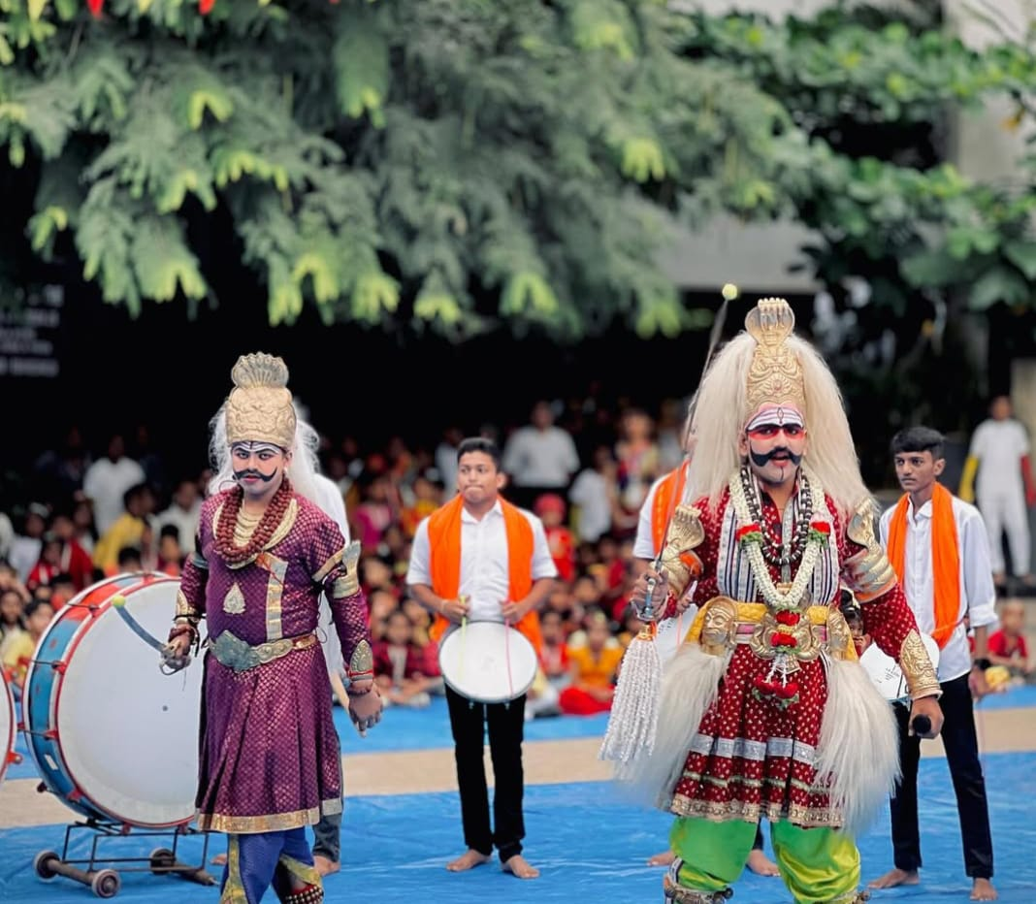

FACULTY INITIATIVES / CONTRIBUTION
Research Activity

Sl.no | Title of paper | Name of the author/s | Department of the teacher | Name of the journal | Volume & Issue
1 | Optimized Cloud Computing IOT Resource Allocation With An Enhanced Ant Colony Approach | Dr Jeelan Basha G | Department of Computer Application | AIRO JOURNALS | Volume 3 Issue 2 Dated August 2024
2 | Effective Resource Distribution Techniques for IOT on Cloud Computing | Dr Jeelan Basha G | Department of Computer Application | International Advance Journal of Engineering , Science and Management | Volume 21 Issue I  June 2024
3 | Utilizing a dynamic source routing  protocol (EIGRP) approach can enhance energy efficiency in wireless  sensor networks | Dr Gowreeswaran D, Dr. Padma | Department of Computer Application | Journal of propulsion technology | vol.45  January 2024.
4 | Responsive  Portfolio Website using REACT | Dr Gowreeswaran D, | Department of Computer Application | Futuristic Technologies | November 2023
5 | Real-Time Intelligent Video Surveillance System using Recurrent Neural Network | Prof Pooja BR | Department of Computer Application | Procedia Computer Science | Volume 235  May 2024
6 | SEPARATION OF BLUE BALL POINT PEN INKS - A COMPARISON OF SOLVENT SYSTEM ON THIN LAYER  CHROMATOGRAPHY | Prof. Deepika Devadas Patkar | Department of Forensic Science | International Journal of Cultural Studies and Social Sciences | Vol-20, Issue-02, No.19, July - December: 2024
7 | A STUDY ON EMPLOYEE ATTRITION WITH REFERENCE TO SWITCHING TECHNOLOGIES GUNTHUR LIMITED
  International Journal of Advance research and innovative ideas in education | Volume- 5 Issue-2 2019 | Prof. S. TAMIL SELVAM | Department of Business Administration

STUDENT ACADEMIC ACHIEVEMENTS
The College has provided our students a healthy and fairly competitive atmosphere in both curricular and co-curricular activities to help them to grow in every sphere of activity. Here is the glimpse of achievements by our students in their academics. The best outgoing students for the academic year 2023-2024:
    - MBA - Mr. Dharshan
    - MCA - Ms. Manasa
    - BBA - Ms. Varsha

PG RESULT ANALYSIS

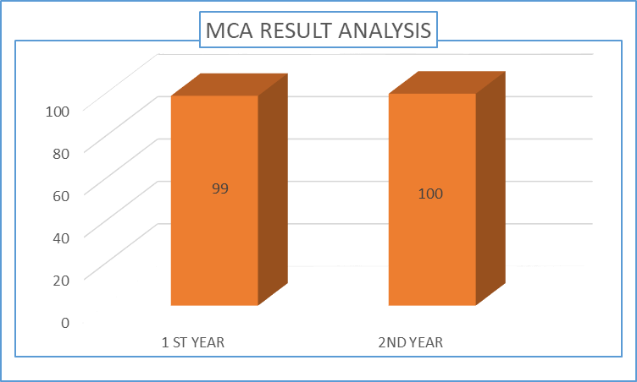

MBA RESULT

UG RESULT ANALYSIS

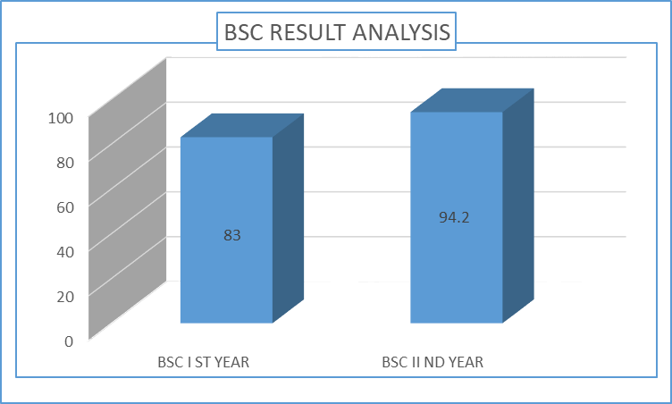

CONCLUSION:

As we reflect on the past year, we are proud of our accomplishments and grateful for the opportunities to serve. In conclusion, the past year has been a period of significant growth and progress at Harsha Institute of Management Studies. Through academic rigor, innovative research, and practical application, we have successfully met the evolving challenges of both the business world and the educational landscape. Our faculty, students, and partners have worked collaboratively to foster a culture of excellence and adaptability, ensuring that our programs remain at the forefront of the industry. As we move forward, we remain committed to empowering the next generation of leaders and managers with the knowledge, skills, and mindset to drive positive change in an increasingly dynamic global environment. We look ahead with enthusiasm, eager to build on our successes and further elevate the standards of management education.

